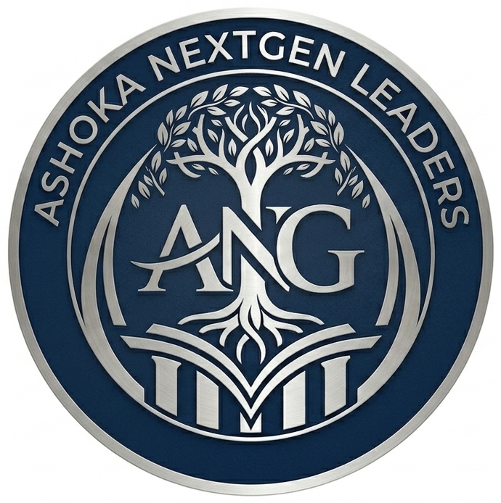
ASHOKA NEXTGEN LEADERS
Where Legacy Meets Critical Thinking

YEAR 1 BUDGET PLAN
Academic Year 2026–27 · Financial Year July 2026 – June 2027
Submitted to: Student Life Office, Ashoka University
Prepared by: Suryansh Dalmia & Madhav Wadhwani · April 2026

Funding Model
The Ashoka NextGen Leaders club is fully self-funded. It makes no funding request of the Student Life Office and will not draw on university seed capital. All income will be raised through voluntary member contributions, approved external sponsorships, and approved institutional partnerships. Every sponsorship arrangement is subject to prior written SLO approval and a conflict-of-interest review in accordance with the club's charter.
No expenditure will be made without prior written approval from the Student Life Office. All figures below are projections and will be revised as actual costs are confirmed.

01 Budget Summary

Total Projected Income | INR 79,000 | (cash + estimated in-kind)
Total Projected Expenditure | INR 62,900 | (across all categories incl. contingency)
Projected Year 1 Surplus | INR 16,100 | (held in reserve for Year 2 launch costs)

02 Projected Income

All sponsorships and partnerships listed below are subject to prior written approval from the Student Life Office and a full conflict-of-interest review. No agreement will be signed or commitment made without SLO clearance.

Category | Item / Description | Qty | Unit Cost | Total
Fundraising
 | Membership contribution (optional, voluntary) | ~30 members | INR 200 | INR 6,000
 | Flagship Speaker Series sponsorship | 1 sponsor | INR 15,000 | INR 15,000
 | Annual Conference sponsorship | 2 sponsors | INR 20,000 | INR 40,000
 | Workshop co-sponsorship (family business networks) | 1 sponsor | INR 10,000 | INR 10,000
 | In-kind support (venue / catering from partners) | — | — | INR 8,000

Total Projected Cash Income: INR 71,000 | Estimated In-Kind Support: INR 8,000

03 Projected Expenditure

All expenditure items require itemised approval from the Student Life Office before any payment or commitment is made. Reimbursements will be submitted with full receipts within 10 working days of expenditure.

Category | Item / Description | Qty | Unit Cost | Total
Events & Programming
 | Speaker Series (×2 sessions) — logistics, AV, materials | 2 | INR 4,000 | INR 8,000
 | NextGen Dialogues (×2) — intimate format, minimal cost | 2 | INR 1,500 | INR 3,000
 | Case Study Workshops (×2) — case printing, facilitation | 2 | INR 2,000 | INR 4,000
 | Governance Workshops (×2) — materials, guest expenses | 2 | INR 2,500 | INR 5,000
 | Founder to Family Panel — AV, materials | 1 | INR 3,000 | INR 3,000
 | State of Family Business session — data report printing | 1 | INR 1,500 | INR 1,500
 | Annual Conference (planning begins Sem 1) | 1 | INR 25,000 | INR 25,000
 | Inter-Club Collaboration Event — shared costs | 1 | INR 2,000 | INR 2,000
 | Clubs & Societies Fair stall — display, print materials | 1 | INR 1,500 | INR 1,500
 | Jashn-e-Jazba — creative showcase materials | 1 | INR 1,000 | INR 1,000
Community & Mentorship
 | Peer Learning Circles (×2) — room, refreshments | 2 | INR 1,200 | INR 2,400
 | Mentorship Programme — matching event, materials | 1 | INR 1,500 | INR 1,500
 | Member Onboarding — welcome kit, printed materials | 1 | INR 2,000 | INR 2,000
Outreach & Communications
 | Club branding — posters, digital assets, social media | — | — | INR 2,500
 | Research Showcase — printing, binding | 1 | INR 1,500 | INR 1,500
Administration
 | Contingency reserve (10% of total expenditure) | — | — | INR 6,000
 | Appraisal report production — printing, binding | 2 | INR 500 | INR 1,000

Total Projected Expenditure: INR 62,900 (including INR 6,000 contingency reserve)

04 Financial Controls & Compliance

- No member may make any payment or financial commitment without express written SLO approval.
- All expenditure submissions signed by the President and filed by the Treasurer / Financial Officer.
- Receipts submitted within 10 working days; personal expenses not accepted.
- Contingency reserve may only be drawn with specific SLO approval for each use.
- A complete financial ledger will be submitted to the Student Life Office at the end of each appraisal cycle.
- Any variance of more than 15% from a line item will be flagged to the SLO in advance.

All projected figures are estimates prepared in good faith. Actual income and expenditure will be tracked monthly and reported in full at Appraisal I (November 2026) and Appraisal II (April 2027).

Ashoka NextGen Leaders · Year 1 Budget Plan · April 2026

