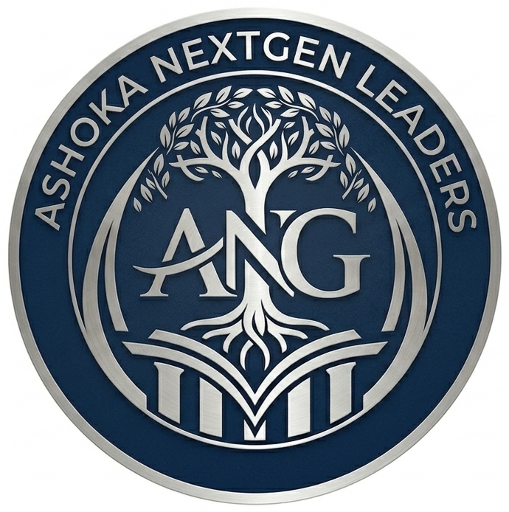
ASHOKA NEXTGEN LEADERS
Where Legacy Meets Critical Thinking

YEAR 1 PROGRAMMING CALENDAR
Academic Year 2026–27 · Semester 1: September – December 2026
Submitted to: Student Life Office, Ashoka University
Prepared by: Suryansh Dalmia & Madhav Wadhwani · April 2026

Notes on this Calendar
All events are subject to prior approval by the Student Life Office and the faculty advisor. Large-scale events and off-campus activities will be submitted for approval well in advance. This calendar is indicative and will be shared formally with the Student Life Office at the start of each semester as required by policy.
Semester 2 (January–April 2027) calendar will be submitted separately at the start of that semester.

Vertical Colour Key

Governance | Legacy | Innovation | Community | Outreach | Mandatory / Cross-club

Each event is colour-coded by the vertical responsible for it. Cross-club or mandatory events appear in the neutral silver shade.

September 2026

Period | Week | Vertical | Event & Description | Lead
September 2026 | Week 1  1–5 Sep | — | Official Club Launch  Open launch event for all Ashoka students; membership applications open; club introduction and vision presented by co-founders. | President
September 2026 | Week 1  1–5 Sep | — | Clubs & Societies Fair  Mandatory participation; club stall, membership drive, and distribution of overview materials. | Community
September 2026 | Week 2  8–12 Sep | Community | Member Orientation & Onboarding  Welcome session for all new members; overview of five verticals, how to get involved, and Year 1 programming roadmap. | Community
September 2026 | Week 3  15–19 Sep | Governance | Workshop 1 — What Is Family Governance?  Introductory workshop on family constitutions, ownership vs. management, and why governance matters in multigenerational businesses. | Governance
September 2026 | Week 4  22–26 Sep | Outreach | Speaker Series — Session 1  Termly speaker: founder or successor from a prominent Indian family enterprise. Fireside-style conversation, open to all students. | Outreach

October 2026

Period | Week | Vertical | Event & Description | Lead
October 2026 | Week 1  29 Sep–3 Oct | Legacy | NextGen Dialogue 1  Intimate conversation with a second- or third-generation business leader. Small-group format, curated questions from members. | Legacy
October 2026 | Week 2  6–10 Oct | Innovation | Workshop — Digital Transformation in Legacy Businesses  Case-based session exploring how established family firms are navigating technology adoption and professionalisation. | Innovation
October 2026 | Week 3  13–17 Oct | Community | Peer Learning Circle 1  Structured small-group discussion session. Members from family business backgrounds share experiences; open reflection format. | Community
October 2026 | Week 3  13–17 Oct | Community | Mentorship Programme Launch  Matching of current students with Ashoka alumni who have returned to family enterprises. Kick-off session with paired introductions. | Community
October 2026 | Week 4  20–24 Oct | Governance | Case Study Workshop 1 — 'The Succession Dilemma'  Real Indian family business succession case studied in classroom format. Group analysis and structured debrief. | Governance

November 2026

Period | Week | Vertical | Event & Description | Lead
November 2026 | Week 1  27–31 Oct | Legacy | 'Founder to Family' Panel  Panel tracing the transition from founder-led to institutionalised enterprise. 2–3 panellists across generations of a single business. | Legacy
November 2026 | Week 2  3–7 Nov | — | Jashn-e-Jazba  Mandatory participation. Club members showcase a creative expression of the club's theme and identity. | President
November 2026 | Week 2  3–7 Nov | Outreach | Inter-Club Collaboration Event  Joint event with one other registered Ashoka club (e.g. Business Club or Entrepreneurship Club) on a shared theme. Satisfies per-appraisal-cycle collaboration requirement. | Outreach
November 2026 | Week 3  10–14 Nov | Innovation | Research Showcase — Family Business in India  Members present short research pieces or opinion essays on family enterprise trends. First iteration of the club's publications initiative. | Innovation
November 2026 | Week 4  17–21 Nov | Outreach | Speaker Series — Session 2  Second termly speaker. Focus on a professional manager (non-family) who has led or advised a major Indian family business. | Outreach
November 2026 | Late Nov | — | Appraisal I Submission  Full appraisal report submitted to Student Life Office covering Sep–Nov activities, membership records, financial ledger, and advisor feedback. | President / Treasurer

December 2026

Period | Week | Vertical | Event & Description | Lead
December 2026 | Week 1  1–5 Dec | Governance | Annual 'State of Family Business in India'  Data-driven session on sector trends, governance developments, and generational transitions. External data sources + member-led presentation. | Governance
December 2026 | Week 2  8–12 Dec | Community | Mentor Check-In & Mid-Year Reflection  Mentorship pairs reconvene for a structured mid-year review. General body reflection session on Semester 1 programming. | Community
December 2026 | Week 2  8–12 Dec | Legacy | NextGen Dialogue 2  Second intimate dialogue session. Year-end format — slightly longer, alumni-facing. | Legacy
December 2026 | Week 3  15–19 Dec | — | End-of-Semester Review & Planning  Internal leadership meeting: review of Semester 1, feedback consolidation, and early planning for Semester 2 (Jan–Apr 2027). | President

Ashoka NextGen Leaders · Year 1 Programming Calendar · April 2026

